Name: Farwa Ahmad

Roll number: MCSF19M024

Subject: Mobile Computing Week 3

GitHub link of Week 3 Application: [MC_Progress/03WeekApplication/Views_GridLayout at master · farwa-ahmad/MC_Progress (github.com)](https://github.com/farwa-ahmad/MC_Progress/tree/master/03WeekApplication/Views_GridLayout)

# Lecture 5 – Android Studio IDE – Constraint Layout

**Task: Create three views**

* 1. 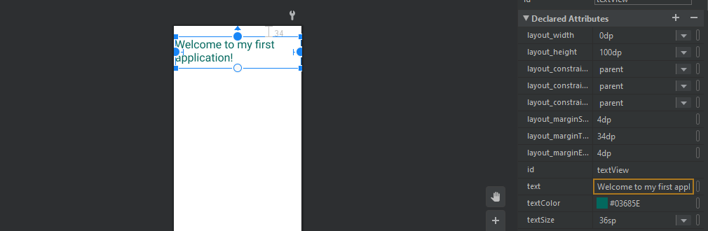**Edited text, changed its color and size.**
  2. 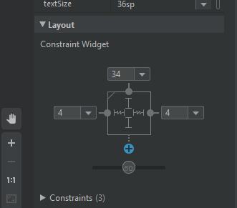**Set Margins and Constraints around the text.**
  3. 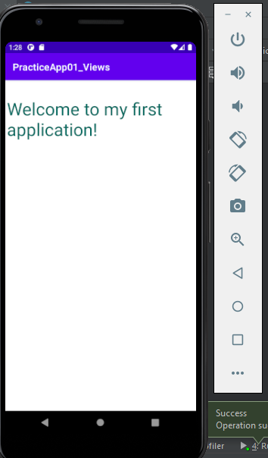**Built the project, testing it on an emulator.**

1. **Added text fields and a button. Adjusted their constraints.**

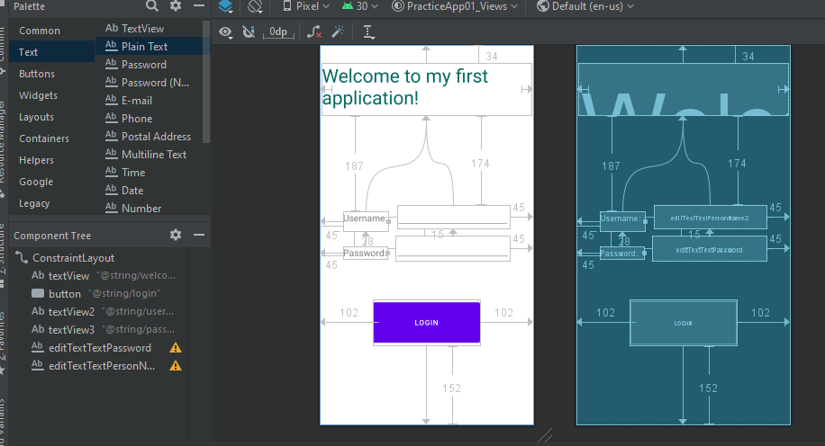

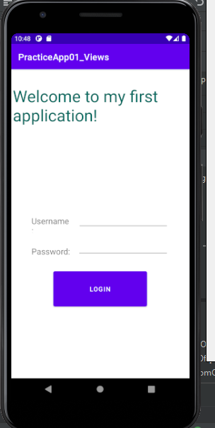

1. **Added another button and adjusted its constraints.**